**Multiplaning**

Studata > GDT 225 > Course Data

Trees.ai

Open AE

Create a new comp

Import Trees.ai into AE

* Import as composition retain layer sizes
* Drag AI files down to time line
* Layer them as follows;

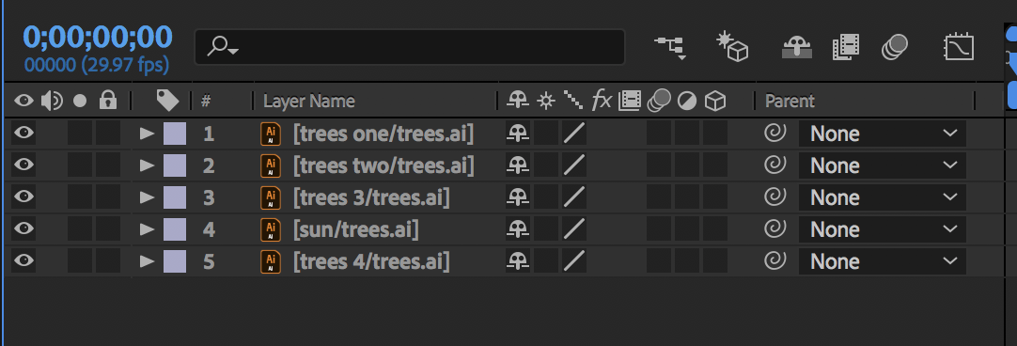

Turn off the sun/trees layer

Stretch out all the tree layers until each layer covers entire composition.

**Sun**

* Turn Sun layer on.
* Position the sun outside and lower left of the comp area.
* Press P, click stopwatch for position.
* Go to 4 seconds
* Move Sun to the middle upper part of composition. Curve the line so that the Sun arcs.
* Go to 8 seconds
* Move the Sun to the lower right and outside of comp area. Keep line in a arc.
* Clean up layer and turn the Sun layer off.

Save.

**All Tree layers**

* Select all the tree layers
* Move all the layers to the left until the edge of the layers or trees shows.

**Null Object**

When it’s not clear which layer to make a “Parent” the solution is to hire a babysitter. A null object.

Null layers do not render. The appear in the shape of a square. Null layers have normal transform properties.

A null’s anchor point defaults to the upper left hand corner.

* New layer > Null object
* Select all the tree layers (not the sun) and using the Pick Whip tool, parent the selected layers to the Null layer.
* Deselect the layers.
* Press P on the Null layer
* Press Home
* Click on stopwatch
* Press End
* Scrub the x value to the left until the tree layers edges show up

Save.

Click on the 3D box on each tree layer (not the sun)

Select all the tree layers. (Not the sun layer or the Null layer)

Press P to open all the layers

**View**

* Change the view to 2 Views vertical
* Click on the top view and it should be the Active Camera
* Click on the bottom view and it should be top—this will show the view from the top point of view.

**Position**

* Press End
* Select all tree layers and Press P for position
* Deselect all tree layers
* Starting with trees one, scrub the Z position to about -300.
* Trees two, scrub the Z position to -130.
* Trees 3, scrub to the Z position to 122.
* Trees 4, leave at 0.

Notice that you did not have to add any key frames.

Save.

Render.